***Intelligent Sootblowing through Knowledge Capture & Advanced Data Analytics***

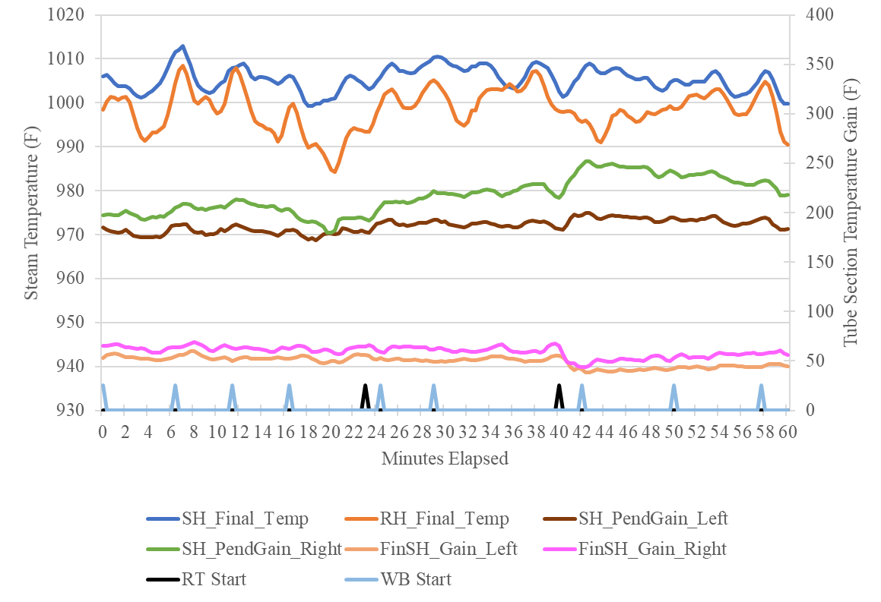Sootblowing at a coal-fired power plant is often a determining factor between operation being smooth and efficient or disjointed and irregular. The conditions affecting soot buildup are constantly changing, so the control systems that address buildup must readily adapt to provide the prime balance of cleanliness to ***protect tubes and maximize heat transfer.***

Taber’s Knowledge-based SootBlowing (KSB) system uses advanced data analysis to ***recognize the effect of each individual sootblower*** across the unit and leverages this knowledge together with the experience of operators to optimally clean the unit and maximize performance while also minimizing the number of blower activations, representing ***reduced tube erosion*** and ***heat rate improvements of 0.6%+***.

Finishing SH Temp Gain Chg

Add intelligence and efficiency to your soot management today by contacting [info@taber-intl.com](mailto:info@taber-intl.com), and learn more about the unique software platform at [www.griffinopensystems.com](http://www.griffinopensystems.com).